Class-2

box model:
padding,width,margin,content
basically we write something and give above configs.

Box sizing:
1.content-box-> as long as content increase box size increase. It is default
2.border box-> box size is not gng to change
use over flow: scroll or hidden to deal with extra content outside box.
Scroll-> x over flow or y over flow
overflow-x or overflow-y
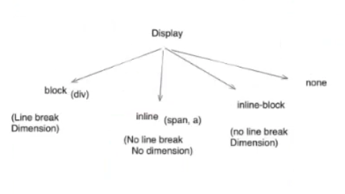

display: none-> will make text not to display.
Remember flipkart dropdown example, when we close dropdown nothing is displayed.

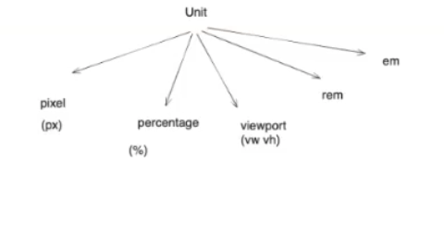

viewport-> inspect example.
Rem-> double or decrease by double of the size given in html level or any other level
em-> doesnt care about root level or default level, it just makes half of the size of text.

